Warning – Snow Plow Mode Active – P552 Only - CGEA 1.3

Functional Description

The purpose of the Snow Plow Mode active warning is to inform the customer that functionality of certain electrical features like heated seats and heated steering will be restricted due to activation of the snow plow. The feature are restricted to enable the snow plow to functional at full power.

This feature is specific to the F150 program, it is not to be implemented on any heavy/super duty trucks (F250+)

The Snow Plow Mode Active Warning correlate the SnowPlowMde_B_Enbl signal and the Operational_Mode to determine when to display the warning.

Interfaces

Interface Context Diagram (I/O Block Diagram)

Figure 1 Warning – Spinout Detected Warning Function Context Diagram

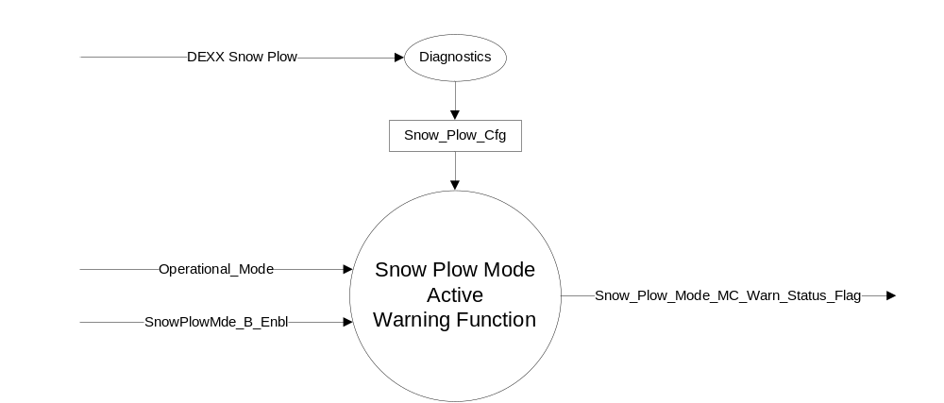

Inputs
      - INTERNAL:
            - Operational_Mode
            - Snow_Plow_Cfg
- MUX message from the CAN bus

- SnowPlowMde_B_Enbl Signal
Signal Name | Size (bits) | Detail | Units | Res. | Offset | State  Encoded | Min | Max
SnowPlowMde_B_Enbl | 1 |  | SED | 1 | 0 |  | 0 (0x0) | 1 (0x1)
 |  | Disable |  |  |  | 0x0
 |  | Enable |  |  |  | 0x1

Outputs
Snow_Plow_Mode_MC_Warn_Status_Flag that is used to control the Warning displayed in the message center.

Function/Performance

Operational Modes

Mode | Differentiating Vehicle Conditions
Sleep Mode | Inactive
Limited Mode | Inactive
Normal Mode | Snow Plow Mode Active Warning Message Active/Inactive
Crank Mode | Snow Plow Mode Active Warning Message Active/Inactive

Voltage Levels

Refer to the Cluster Features Table located in the Operational Modes and Voltage Range Strategies Section of this SPSS.

Human-Machine Interface

Visual

Indicator Graphics / Display Format
Reference the following Message IDs in the Text Message List file for the appropriate display: W3278

1.3.3.1.2 Indicator Color Coordinates

Reference section COLOR & ILLUMINATION REQUIREMENTS (GRAPHICS)

1.3.3.1.3 Indicator Characteristics

Refer to Message Center X Display_Y Button Interface Section, where X and Y are appropriate values in this document.

Audio

None,

Switch Control Logic

Consumer access to Message Center Warnings shall be as specified in the Message Center X Display_Y Button Interface Section, where X and Y are appropriate values in this document.

System Accuracy

The state of the message center flags shall change within 100 msec of a state change as indicated in the state matrix found in section 1.3.5.1 of this document.

Operation: Performance and Functional

Subsystem Algorithm Flowchart / State Diagram

- State Matrix for Snow_Plow_Mode_MC_Warn_Status_Flag
Operational Mode | Snow_Plow_Cfg | SnowPlowMde_B_Enbl Signal | Snow_Plow_Mode_  MC_Warn_Status_Flag
Normal or Crank | Enabled (0x1) | 0x1 (Enable) | Active
All other Cases |  |  | Inactive

- Snow_Plow_Mode_MC_Warn_Status_Flag to MC Warning Message ID
Snow_Plow_Mode_MC_Warn_Status_Flag | MC Message ID
Active | W3278

Operation Description (supports algorithm flowchart /state diagram)

- For definition of how the Message Center arbitrates and displays Active warnings, see the Message Center – X Display with W Button Interface section of this SPSS (where X and W are appropriate values in this document).

Function Safety Classification (EMC)

Class B

Memory Storage

Parameter Name | Description | Value at  Battery Connect | Value at  Module Wake-up
Snow_Plow_Mode_MC_Warn_Status_Flag | Used to control the state of the warning to the Message Center arbitrator | Inactive (0x0) | Inactive (0x0)
SnowPlowMde_B_Enbl Signal | Input CAN Signal from the FCIM | Disable (0x0) | Disable (0x0)
Snow_Plow_Cfg | State Indicator for feature presence controlled via CAN at EOL at VO plant. Defaulted to DISABLED at supplier manufacturing. | Use Stored Value | Use Stored Value
Operational_Mode | 4 state indicator for cluster operational mode | Limited | Limited or Normal or Crank

Prove Out

No.

Reconfigurable Telltale

No.

Message Center Msg

Refer to Text: Program Master Warning Message List.xls | Program Translation Table.xls warning W3278.

Error Handling

Missing Message/Undefined Data Strategy

None.

Diagnostics

Self Test

None

Engineering Test Mode

Not Applicable

Part II Performance

Supported Diagnostic DIDs (Service $22 and $2F)

Supported Diagnostic Trouble Codes (DTCs)

DID DEXX Configuration
Block  Num | Block Description | Size  (bits) | Byte(s) | Bit | State: Description | "0" | "1" | Default | Comments/Information
PACKETED BLOCKS
$XX | Option Content  (B&A) | 1 | * | * | Snow Plow | Disabled | Enabled | Disabled | Feature expected to be enabled on F150 only.
*Byte and bit location to be identified in Part II Specification for this cluster

Reference Specification

IS-0001 WARNINGS/INDICATORS/DISPLAYS PROVEOUT
IS-0052 OPERATING VOLTAGES - FUNCTIONAL/PERFORMANCE
IS-0069 FUNCTIONAL IMPORTANCE CLASS
IS-0324 WINDSHIELD & OTHER REFLECTIONS
IS-0327 WARNING INDICATOR EVALUATION
IS-0379 NORTH AMERICAN WARNINGS AND INDICATORS STRATEGY

IL-0017 TELLTALE AND INTERIOR ILLUMINATION – COLOR AND INTENSITY
IL-0019 GENERAL ILLUMINATION DIMMING
IL-0021 CRAFTSMANSHIP – DISPLAYS
IL-0022 GENERAL ILLUMINTATION COLOR
IL-0023 CLARITY/LEGIBILITY/READABILITY/VISUAL CONTRAST
IL -0043 OPERATIONAL ENVIRONMENT FUNCTIONALITY
IL -0045 COLOR
IL -0047 TELLTALE, INDICATOR AND DISPLAY LIGHT INTENSITY
IL -0048 ILLUMINATION ACCEPTABILITY

03-0661 PLACEMENT: CONTROL AND DISPLAY LOCATIONS
03-0662 PLACEMENT: LOGICAL GROUPING FUNCTION AND USAGE
03-0664 PLACEMENT: DOWN VISION TO COMPONENTS WITH HIGH VISUAL DEMAND
03-0665 PLACEMENT: EXPECTED LOCATIONS OF CONTROLS AND DISPLAYS VDS
03-0670 INTERIOR VISIBILITY
03-0671 INTERIOR VISIBILITY: REFLECTIONS FROM COMPONENTS & SURFACES
03-0672 INTERIOR VISIBILITY: REFLECTIONS IN DISPLAYS
03-0673 INTERIOR VISIBILITY: VISUAL OBSCURATIONS
03-0674 INTERIOR VISIBILITY: ILLUMINATION CONTROLS / DISPLAYS
03-0675 INTERIOR VISIBILITY: VEILING GLARE
03-0677 INTERIOR VISIBILITY: SUNLIGHT WASHOUT
03-0681 IDENTIFICATION: CHARACTER AND SYMBOL SIZE
03-0682 IDENTIFICATION: LEGIBILITY
03-0685 IDENTIFICATION: SYMBOLS, ABBREV FOR CONTROL
03-0721 LOGIC OF OPERATION: OPERATIONAL STEREOTYPES
03-0722 LOGIC OF OPERATION: INTERPRETATION
03-0723 LOGIC OF OPERATION: USE OF SYSTEMS WITH VISUAL DISPLAYS

Revision History

SPSS Module Revision History

Revision Level | Name | Change Description | Date
1.0 | V. Patel | Initial Release (Feature owner Mike Irby) | 4/17/2013

